

MAXIMISE 22.1

INSTALLATION GUIDE

Prepared by Maximise| 29 March 2022

@Copyright 2022 Version 1 – All Rights Reserved

**Table of Contents**

1 Introduction 3

1.1 Purpose 3

2 Database Implementation 4

2.1 DBA Prerequisite Tasks 4

2.2 Assumptions 5

3 Maximise Code Installation 6

3.1 STEP 1: Prepare 6

3.2 STEP 2: Installation 9

3.3 STEP 3: OIC 11

3.4 STEP 4: VBCS 15

**Version Control**

|  |  |  |  |
| --- | --- | --- | --- |
| Date | Version | Changed By | Reason for Change |
| 21-Jul-2021 | 1.0 | Lokesh Shanbhag | No previous version. |
| 13-Jan-2022 | 2.0 | Pallavi Kanajar | Updated Installation document for OIC installation |
| 28-Feb-2022 | 3.0 | Joe Lalor | Installer Updates |
| 29-Mar-2022 | 4.0 | Praveen Nair | Install Doc Formatting and Release Update for 22.1 |

Circulation List

|  |  |
| --- | --- |
| Name | Organisation/Title |
| Ken MacMahon | Version 1 |
| Bridget Morrissey | Version 1 |
| Praveen Nair | Version 1 |

Glossary

The following terminology and abbreviations are used throughout this document:

|  |  |
| --- | --- |
| Term | Description |
| EBS | Oracle e-Business Suite (general term) |
| OS | Operating System |
| OU | Operating Unit – A Business Structure Entity to which specific data can be associated. |
| R11i | Oracle e‑Business Suite R11i |
| Maximise | Version 1’s Cloud Data Migration accelerator framework. |
| R12 | Oracle e‑Business Suite R12 |
| TBC | To Be Confirmed |
| TBD | To Be Determined |
| DBAAS | Database As a Service |
| DBA | Database Administrator |
| TNS | Transparent Network Substrate |

# Introduction

## Purpose

The purpose of the installation document is to provide a reference at any time for the Implementation team working on a Maximise Installation. This document describes the key requirements of Database configuration and assumptions which should be taken into consideration before installing Maximise Data Migration components. The document also covers the installation sequence with detailed steps described in Section 3.

On a practical level, the requirements will have a continuing influence on the scope and content of the architecture design work throughout the project life; therefore, it is important that the list is as complete as possible and agreed early during the Elaboration Phase of the project. The architecture team will need to keep these requirements in mind throughout the project and help create an architecture that is compatible with the Maximise requirements. Furthermore, if the architecture requirements alter mid-project, the changes should be noted and disseminated in a timely manner.

This document should be distributed to all Implementation team members who will be responsible for deploying Maximise code installation in Client’s database environment. Subsequent changes to the architecture scope will be communicated universally before implementation of these changes begins.

The project manager can use this document to understand how the delivery team plans to conduct Maximise installation and communicate required Database requirements as well as assumptions to the client.

The installation process allows customisation by the delivery team. This may fulfil a particular client’s requirements. If the delivery includes a customisation which may benefit delivery for other clients, please communicate this to the development team.

|  |
| --- |
| **Note**: As the installation will drop and re-create objects, it is recommended that a backup of all required objects is taken before the installation (especially on instances where Maximise DM is being re-installed) |

# Database Implementation

This section outlines the Database requirements and associated steps for the DBA to install Maximise. It also highlights assumptions which would be taken under consideration before installing Maximise on Standalone database.

## DBA Prerequisite Tasks

* Create standalone Database (Cloud DBAAS) with the configuration outlined below:

|  |  |
| --- | --- |
| Database parameters | Descriptions |
| DB Type | Standalone DB |
| Shape | VM. Standard2.2 or higher |
| OCPU Count | Minimum 2 |
| Network Bandwidth | 2 GBPS |
| Memory | 30 GB |
| Local Disk | Block Storage Only |
| Capacity type | 500GB Free Storage with On-demand configuration |
| Database System Version | 19.7.0.0.0 Standard Edition or higher |
| Character Set,  National Character Set | AL32UTF8, AL16UTF16 |
| Database Workload | OLTP |
| Pluggable Database Name | MXDM_PDB1 |

* The installation is performed as the *opc* user on the standalone database host, so *opc* logon credentials are required.
* The installation creates database infrastructure by sudoing to the *oracle* user and executing scripts in the opc folder tree. SQLPlus activity is logged to text files in the opc folder tree. Therefore, the *oracle* user requires **Read** and **Execute** permissions on the opc folder during the installation. One way to achieve this is to set Others permissions as follows:

* If migrating from an EBS legacy system, the installation will connect the standalone database to the source EBS database via a Database Link. Therefore, the client network configuration must allow this.
* The SYS password for the Standalone database is required during installation.
* The installation assumes the schema name on the legacy EBS database is *apps*.
* The Oracle connection string (TNS entry), e.g., (DESCRIPTION=(ADDRESS_LIST=(ADDRESS=(PROTOCOL=TCP)(HOST=xx.xx.xx.xx)(PORT=xxxx)))(CONNECT_DATA=(SERVICE_NAME=xxxx))) is required to create the database link for migration from a legacy database.

**Note:** replace the highlighted above with details of the Maximise database

* If re-installing, appropriate backup of database objects including configuration data in tables should be taken

## Assumptions

* The Client’s I.T Department or Version 1 delivery team will be responsible for the database configuration

into which the Maximise Code will be installed.

* All configuration items e.g., Organisation, location, job, grade, talent, position etc are the responsibility of the implementation team.

# Maximise Code Installation

## STEP 1: Prepare

| Seq. | Installation Action | Step Complete | Comments / Notes |
| --- | --- | --- | --- |
|  |  |  |  |
| 1. | Download the latest version of Maximise DM from the following location in Bitbucket:  [Browse Version 1 -ERP Solution Architecture / Maximise DM Production Release - Bitbucket](https://git.version1.com/projects/VESA/repos/maximise-dm-production-release/browse) |  | The installer will be downloaded in a zip file |
| 2. | Login to the standalone database as an *opc* user |  | Use SSH key to login to the standalone database server |
| 3. | Navigate to opc home directory.  cd /home/opc/ |  | Use **pwd** command to find current path in Linux. |
| 4. | Unzip the downloaded file from Bitbucket and transfer the files across to the home directory on the server. Transfer the files in ASCII mode     |  |  |
| 5. | The installation logs its progress to .log files in the install folder, so this folder should allow write access to the Oracle user:   |  |  |
| 6. | Ensure that the xxmx_master_mxdm.sh is available and has execute permissions |  |  |
| 7. | This step applies if Maximise is being installed on an instance where a previous release of Maximise was deployed and the project team has updated/customised the packages provided previously to meet customer requirements. As a re-install of Maximise will drop objects and re-create database objects (including packages), if the project team prefers to re-apply their backup package changes, the installation may be customised via the shell script ***xxmx_custom.sh*** in the Install folder. The script contains a call to xxmx_custom.sql as an example of suggested use. |  | For **BoyleSports**, the R11 package changes can be deployed in this manner. R11 specific scripts will be under the **R11** sub-folder |

### 

## STEP 2: Installation

| Seq. | Installation Action | Step Complete | Comments / Notes |
| --- | --- | --- | --- |
|  |  |  |  |
| 1. | On the server, navigate to the Maximise install directory:  *cd $HOME/Install*  *(assuming the zip file was extracted under $HOME)* |  |  |
| 2. | Execute the install script:  *./xxmx_master_mxdm.sh* |  |  |
| 3. | Detailed logs are written to the Install directory during installation. Use these if the installation is not successful or to verify the installation. |  |  |
| 4. | Create XXMX schemas (Y/N)? (Y)  **Note: This process takes between 2 to 3 minutes** |  | The default is Y to create or re-create the full DB infrastructure |
| 5. | Enter the SYS password for MXDM_PDB1 |  | Provided by DBA |
| 6. | Maximise uses 3 schemas – STG, XFM and CORE – for its infrastructure. Choose a password for the STG schema |  | The maximise schema passwords must consist of at least 9 characters, 2 numerals, 2 uppercase, 2 lowercase and 2 special chars (no quote marks) |
| 7. | Choose XFM SCHEMA password  Choose CORE SCHEMA password |  | XFM and CORE passwords will default to the STG password if left blank |
| 8. | Create DB link to EBS database (Y/N)? (Y) |  | Default is Y |
| 9. | Enter the APPS password for EBS database |  | The legacy EBS schema name is assumed to be APPS |
| 10. | Enter the EBS database connection string  e.g.:  (DESCRIPTION=(ADDRESS_LIST=(ADDRESS=(PROTOCOL=TCP)(HOST=xx.xx.xx.xx)(PORT=xxxx)))(CONNECT_DATA=(SERVICE_NAME=xxxx))) |  | Replace the high-lighted with the details for the Maximise database |
| 11. | Which EBS modules will be migrated?  FIN (Y/N)? (Y)  HCM (Y/N)? (Y)  PAY (Y/N)? (Y)  Maximise Custom Extensions and Core OIC Objects (Y/N)? (Y) |  | FIN = Financials  HCM = Human Capital Management  PAY = Payroll  Y is the default |
| 12. | Review the log files after the installation is complete and check for any database objects that are INVALID |  |  |

## STEP 3: OIC

The following section details the steps required to import the integration package for Maximise OIC.

### Pre-requisites

* Maximise installation is complete and Core OIC Objects are installed
* Access to Oracle Integration Cloud
* Downloaded the latest version of the **maximise.dm.par** package from Bitbucket (this file should be under the Install/OIC folder)

### Import Integration Package

To import the OIC Integration Package:

1. Log on to OIC
2. Click on **Packages**

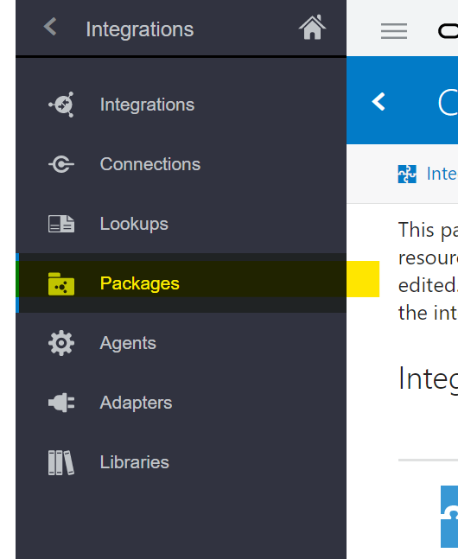

1. Click on the **Import** button

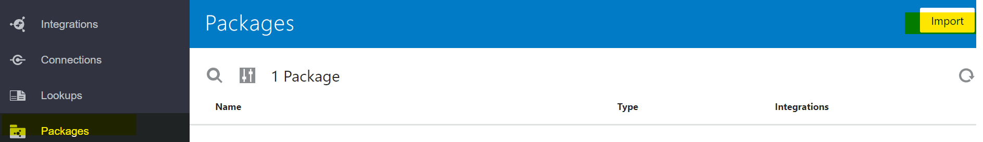

1. Click **Browse** to open a navigation pane
2. Select the integration package archive (.par) file to import

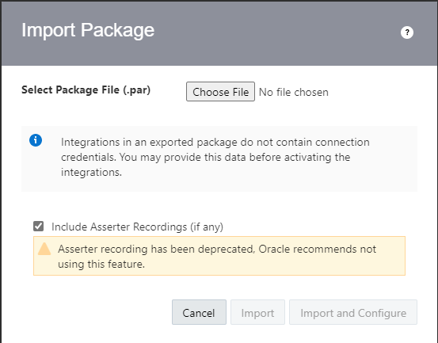

1. Click **Import**. The package is added to the **Packages** list

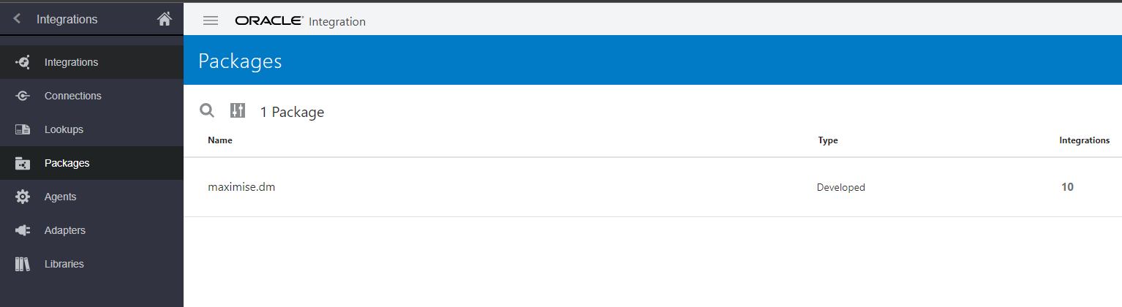

1. The package should import the following integrations
   * INTDM999008 File Archive Process (1.0)
   * INTDM999008 Update Migration Metadata (1.0)
   * INTDM999005 Data Migration Mapping Process (1.0)
   * INTDM999002 DM Extract File Generation (1.1)
   * INTDM999003 DM Transform File Generation (1.0)
   * INTDM999004 Data Migration Load File Generation (1.1)
   * INTDM999001 Data Migration Run Extract Transform (1.0)
   * INTDM999006 Load FBDI to Interface Table (1.0.1)
   * INTDM999007 DM Run Fusion Import Process (1.0)
   * Metadata CRUD - Get (1.0)

### Configure Connections

For the integration to be successful, edit the Connections as required. The connections can be edited from the Packages section as below:

1. Under Packages, click on the **Configure** icon to show a list of Integrations, Connections and Lookups for the package

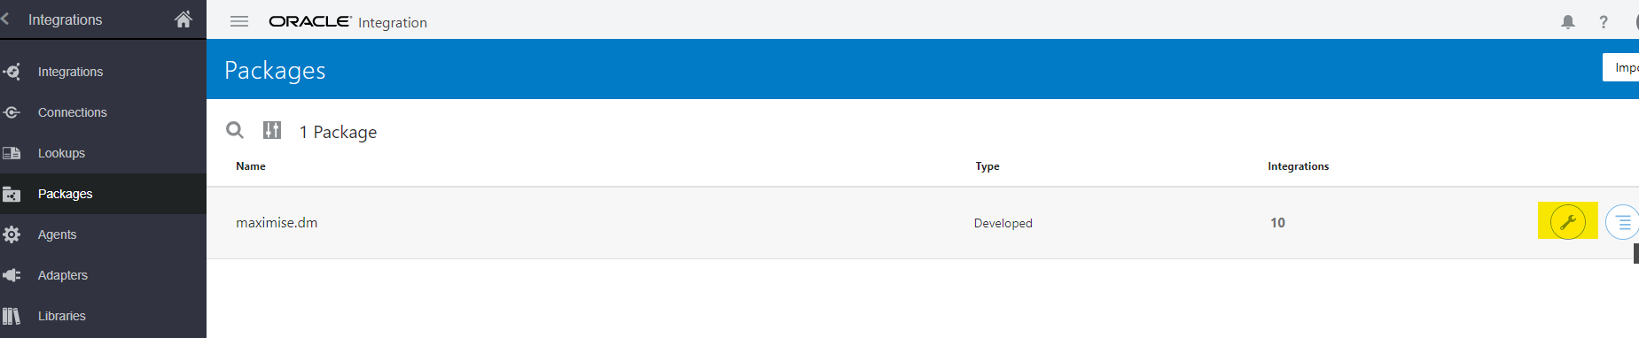

1. Click on the **Connections** link to navigate to the available connections

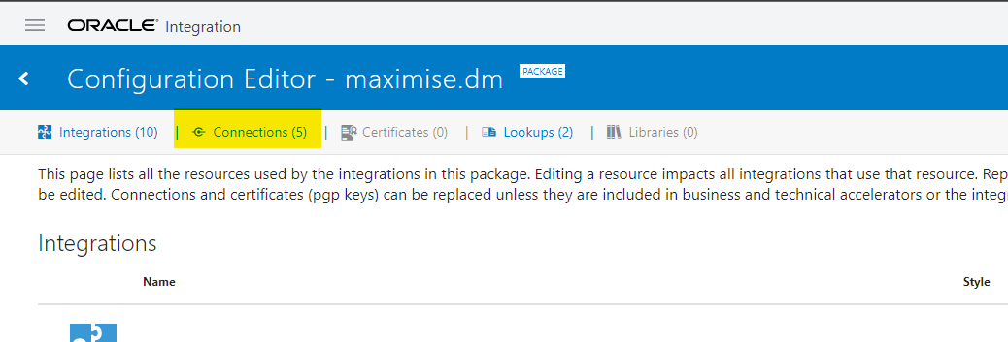

1. Under Connections, all available connections should be displayed

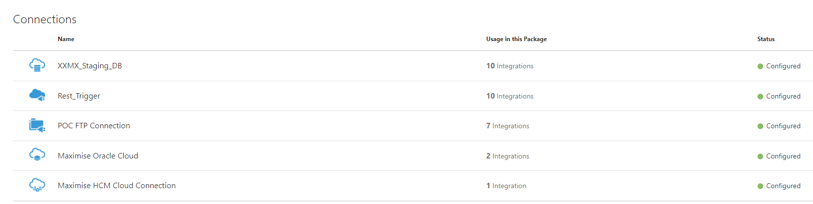

1. To edit the connections, hover the mouse pointer on the connection row to display the **Edit** and **Replace** options

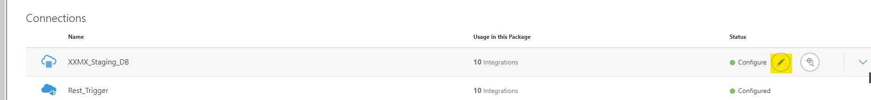

1. Click on **Edit** to edit the connection to change the connection properties, username, password etc.
2. **Save** and **Test** the configuration after making the changes

### Integrations

#### Activate Integrations

On importing the package, the integrations will be imported and should be set as Active. If the status is not active, follow the steps below to activate an integration:

1. Navigate to available Integrations under the Packages > Configuration Editor > Integrations

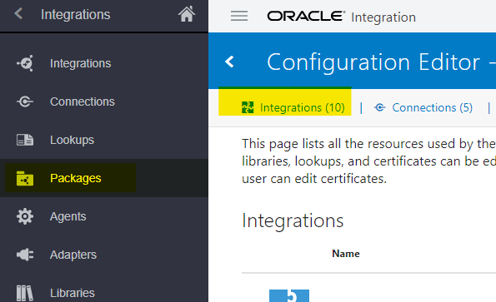

1. Click on the Activate icon to activate Integration (see example below)

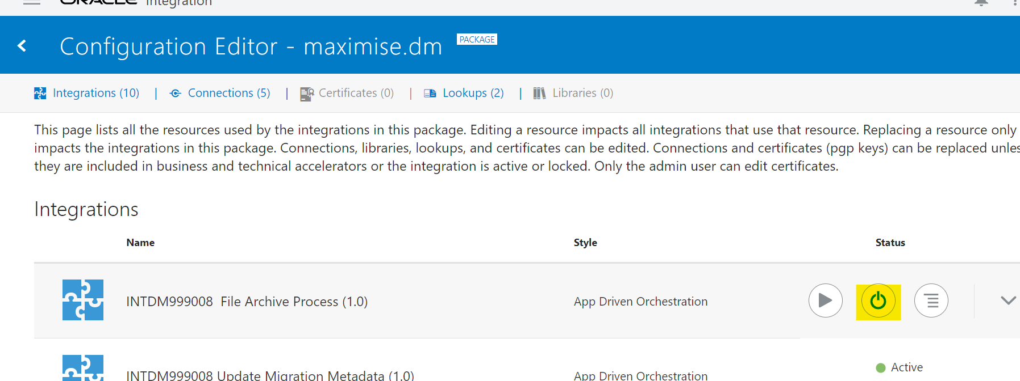

1. Check the **Enable Tracing** box and click on Activate

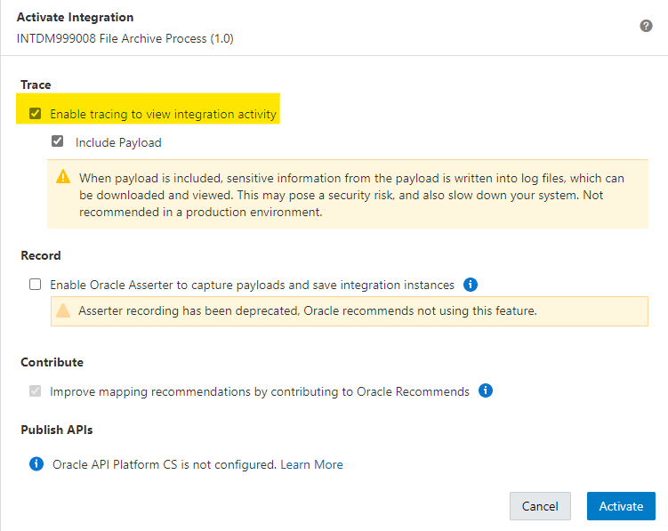

1. Once Integration status is **Active,** test the connections by running the integration

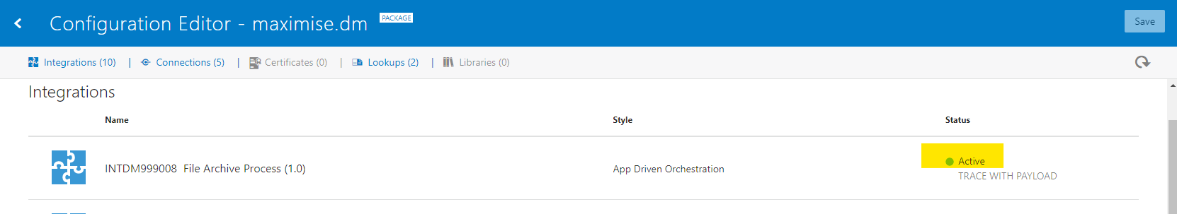

#### Deactivate Integrations

To deactivate an integration,

1. Navigate to Integrations under the Packages > Configuration Editor > Integrations



1. Click on the Deactivate icon (see example below)



1. Integrations can be edited, once the status is Deactivated

## STEP 4: VBCS

### Pre-Requisite

* Maximise installation is complete and Core OIC Objects are installed
* Access to Oracle Integration Cloud
* Downloaded the latest version of the **Maximise_Data_Migration-VBCS_1.0.zip** file from Bitbucket (this file should be under the Install/VBCS folder)

### Installation

1. Login to the Integration server and navigate - Oracle Integration > Home > Visual Builder

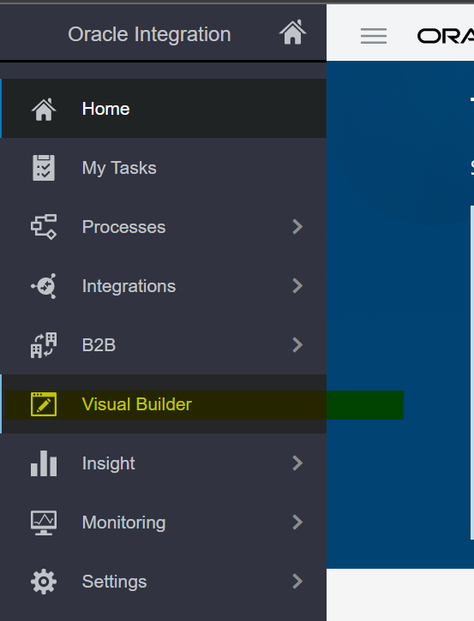

1. Click on **Import Application**

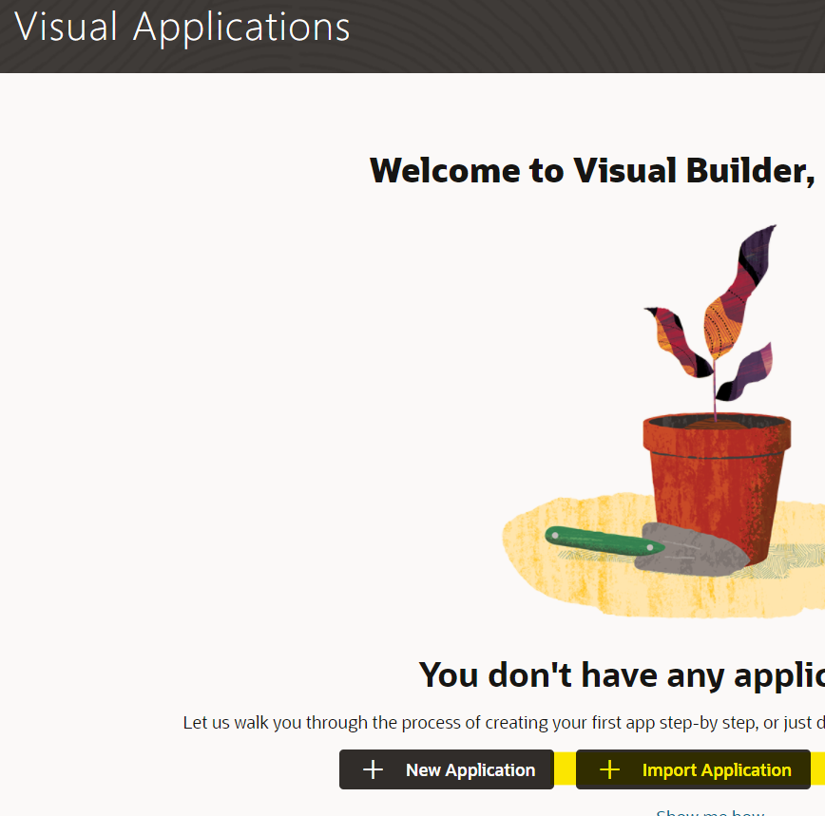

1. Select **Application from file** import option

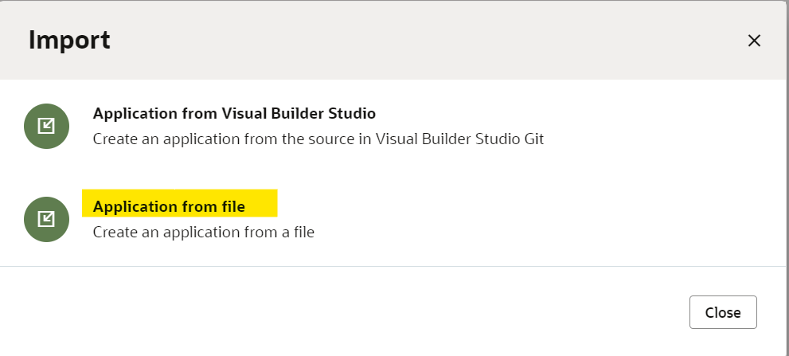

1. Drag and drop the zip file downloaded (covered under the VBCS Pre-Requisite section)

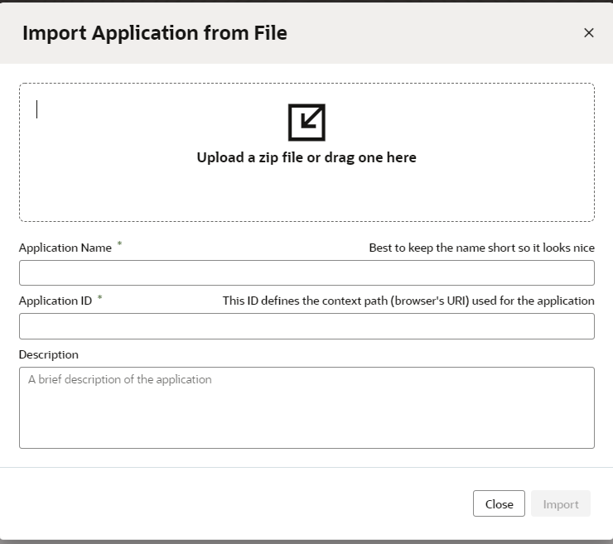

1. Enter the Application Name and Application ID

e.g., Application name: Maximise Data Migration

Application ID: 1234

1. Installation is now complete



[**www.version1.com**](http://www.version1.com)

*`*